**Practical 1: Write a program for tokenization of given input.**

The **java.util.StringTokenizer** class allows you to break a String into tokens. It is simple way to break a String. It is a legacy class of Java.

It doesn't provide the facility to differentiate numbers, quoted strings, identifiers etc. like StreamTokenizer class. We will discuss about the StreamTokenizer class in I/O chapter.

In the StringTokenizer class, the delimiters can be provided at the time of creation or one by one to the tokens.

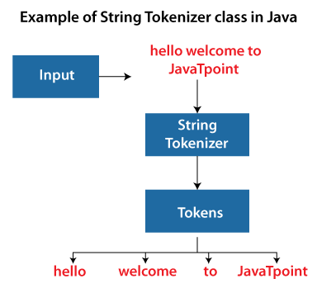

**Constructors of the StringTokenizer Class**

|  |  |
| --- | --- |
| **Constructor** | **Description** |
| StringTokenizer(String str) | It creates StringTokenizer with specified string. |
| StringTokenizer(String str, String delim) | It creates StringTokenizer with specified string and delimiter. |
| StringTokenizer(String str, String delim, boolean returnValue) | It creates StringTokenizer with specified string, delimiter and returnValue. If return value is true, delimiter characters are considered to be tokens. If it is false, delimiter characters serve to separate tokens. |

**Methods of the StringTokenizer Class**

|  |  |
| --- | --- |
| **Methods** | **Description** |
| boolean hasMoreTokens() | It checks if there is more tokens available. |
| String nextToken() | It returns the next token from the StringTokenizer object. |
| String nextToken(String delim) | It returns the next token based on the delimiter. |
| boolean hasMoreElements() | It is the same as hasMoreTokens() method. |
| Object nextElement() | It is the same as nextToken() but its return type is Object. |
| int countTokens() | It returns the total number of tokens. |

**Example of StringTokenizer Class**

1. **import** java.util.StringTokenizer;
2. **public** **class** StringTokenizer1
3. {
4. **public** **static** **void** main(String args[])
5. {
6. StringTokenizer st = **new** StringTokenizer("Demonstrating methods from StringTokenizer class"," ");
7. **while** (st.hasMoreTokens())
8. {
9. System.out.println(st.nextToken());
10. }
11. }
12. }

**Output:**

Demonstrating

methods

from

StringTokenizer

class

The above Java code, demonstrates the use of StringTokenizer class and its methods hasMoreTokens() and nextToken().

**Example of nextToken(String delim) method of the StringTokenizer class**

**Test.java**

1. **import** java.util.*;
2. **public** **class** Test {
3. **public** **static** **void** main(String[] args) {
4. StringTokenizer st = **new** StringTokenizer("my,name,is,khan");
5. // printing next token
6. System.out.println("Next token is : " + st.nextToken(","));
7. }
8. }

**Output:**

Next token is : my

**Example of countTokens() method of the StringTokenizer class**

**This method calculates the number of tokens present in the tokenizer String.**

**StringTokenizer4.java**

1. **import** java.util.StringTokenizer;
2. **public** **class** StringTokenizer3
3. {
4. **public** **static** **void** main(String args[])
5. {
6. StringTokenizer st = **new** StringTokenizer("Hello Everyone Have a nice day"," ");
7. System.out.println("Total number of Tokens: "+st.countTokens());
8. }
9. }

**Output:**

Total number of Tokens: 6